Southampton Tumbling Mike Walker Invitation
Competition Oct 2018
FAQ’s (Frequently Asked Questions or Quires)
Q “If a gymnast has competed in the any regional or national NDP or FIG earlier this year 2018; do they then have to stay at the level or can I enter them at a different one to this comp?”
A “The tumblers can be entered for any level in NDP or FIG grades that coach is qualified to coach at this open event. That means they can change levels between open comps throughout the year based on clubs development plans for that tumbling gymnast.
Extra Notes:
Those who competed at Elite/FIG levels, should really stay at the Elite/FIG levels and NOT jump back into NDP grades within the same competition year, unless the coach feels as revaluation, that the tumbler is competing outside their true tumbling pathway.
Those who competed at NDP grades are OK to compete upward into the Elite/FIG grades, so long as this fits with coaches planned development strategies for the tumblers future pathway.
At national level, Tumbler only has to stay at same level when competing at national qualifying events they were entered for at regional prelims or national qualifiers.”
---------------
Q “How do I work out what age group to put on the registration form for my tumblers?”.
A “The Club, NDP and Elite grades AGE groups are determined by the DOB the tumbling Gymnasts is in the year of the competition. This Graphic should aid you, by example what age group you tumblers is in for each grade level.
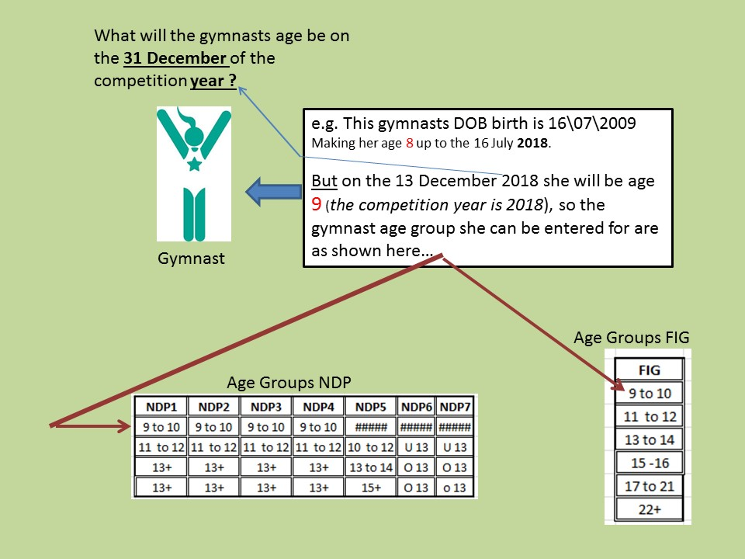
---------------
Q“A regional club is looking to enter about 20 people into the competition. Question is the open competition at Southampton sticking to the age rules? for example this club has some 7 year olds that they would like to enter”.
A “There is no planned out of age category (OOA) for NDP National Levels this event (6/7 years old), however depending on the total number of entries and levels, it might be possible to consider including and OOA group for up to NDP1. Please make a separate enquiry with event organiser about this.
For Club NDP level 1 & 2 there is a 7/8 age category”
---------------
Q“I have a NDP club tumbler who is capable of NDP national level 2 skills. The bg guidelines are that they can only enter NDP club level 3 not national level 2. But I don't really want the gymnast to go backwards to cartwheels and rebound turns?
At this your open competition can the tumbler compete at the higher level ?2”
A “See also pervious FAQ with regard to OOA. But to further confirm you will see that for NDP levels…. that earliest age group that is catered for NDP is 9-10 years in the year of the comp (age of gymnast @ 31st December 2018 must be 9 years old e.g. must be born in 2009)
Medal positions for age groups in NDP will be 1st, 2nd and 3rd for M and W as follows: -”
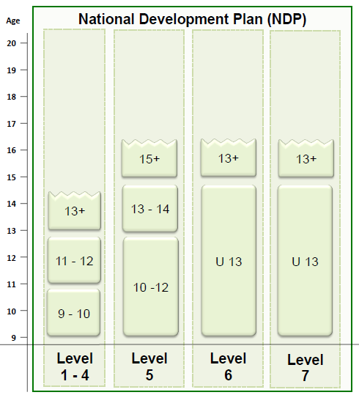
---------------
Q “Are you able to advise if there will be a range and conditioning element to the NDP competition?”
A “No Range and Conditioning element included at this event - this is only a requirement of the regional prelims.”

